**ACROPOLIS INSTITUTE OF TECHNOLOGY AND**

**RESEARCH**

**Department of Information Technology**

Synopsis

On

# Comprehensive Digital Learning System for Students

# 

**Introduction:**

* 1. **Overview:** 
     + **What is Digital Learning System?**

This project focuses on developing a website to provide learning materials in the form of notes to students. The website will serve as a centralized platform for students to access course-related notes, categorized by subjects and topics. The goal is to offer students an easily navigable interface where they can search, download, and interact with educational resources, enhancing their learning experience.

* 1. **Purpose of the project/Innovativeness and usefulness:**

The purpose of this project is to simplify the process of accessing study materials, enabling students to enhance their knowledge in a structured and efficient manner. The primary purposes of this project are as follows:

* + - **Reduce Time:** Reducing the time spent searching across various sources.
    - **Reduce costs:** Reduce manual intervention and chargebacks to save time and resources.
    - **Improve Performance:** This project aims to create an organized repository that will be accessible to all students, improving their academic performance and study habits.

1. **Literature Survey:**

* 1. **Existing Problem:**

The existing systems designed to address sign language recognition have several limitations:

* + - * **Limitations of Traditional Systems:** Traditional approaches involve either relying on textbooks, which may not always be up-to-date, or searching for scattered resources online.
      * **Inability to Adapt:** Some websites provide learning material, they lack proper organization, or easy accessibility with a student’s syllabus.
      * **Challenges with Traditional Methods:** This often leads to confusion, loss of time, and reliance on inadequate resources due to lack of integration with syllabus.
  1. **Proposed Solution:** 
     + - * The proposed solution is to develop a user-friendly website specifically tailored to students’ needs, providing them with well-organized notes for different subjects.
         * The site will be curated with high-quality educational material, ensuring that students have access to reliable content.
         * The platform will prioritize user-friendliness, accessibility, and effective navigation to enhance the learning experience.

1. **Theoretical Analysis:** 
   1. **Block Diagram:**

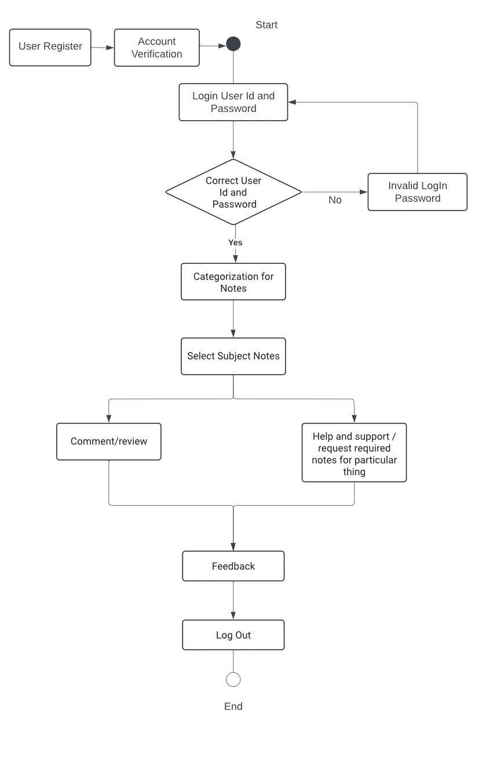

Fig.1 Block Diagram of Comprehensive Digital Learning System

* 1. **Required Resources:**

* + - **Hardware Requirements:**

1. **Computer/Server:** A server or cloud hosting to manage website traffic.
2. **Storage Devices:** User devices (PC, tablets, smartphones) for students to access the site.

* **Software Requirements:**

1. **Front-End:** HTML 5, CSS 3, JavaScript for designing the website interface
2. **Back-End:** Python (Django) 3.13 or PHP for handling requests and managing user interactions.
3. **Database:** MySQL or SQLite for storing notes and user data.
4. **Additional Tools:** Web hosting services (AWS, or local servers).

**4.Applications:**

This solution can be applied in various educational environments, including:

* + - * **Schools and Colleges:** To provide subject-specific notes, helping students prepare for exams.
      * **Online Learning Platforms:** The website can be integrated with other online education services to enhance their offerings.
      * **Corporate Training:** Employees can use this system for self-paced learning or structured corporate training programs.
      * **Exam Preparation:** Provides targeted resources, summaries, and past project references to help students prepare effectively for exams.
      * **Skill Development:** Assists in developing research and analytical skills as students engage with diverse resources and contribute their own notes.

**5. References:**

1. IEEE Xplore. *Digital Tools, Technologies, and Learning Methodologies for Education 4.0 Frameworks: A STEM Oriented Survey*. Retrieved from <https://ieeexplore.ieee.org/document/10401932>
2. Google Scholar (2024). *Academic Papers and Theses on Digital Learning Systems*. Retrieved from <https://scholar.google.com/>.
3. Kumar, V., & Sharma, S. (2021). *E-Learning System for Education 4.0: Concept and Challenges*. *International Journal of Emerging Technologies in Learning (iJET)*. Retrieved from <https://online-journals.org/>.
4. JSTOR (2023). *A Digital Library for Academic Journals, Books, and Primary Sources on Educational Technology*. Retrieved from <https://www.jstor.org/>.
5. Mozilla Foundation (2024). *MDN Web Docs: Web Development Guides and Tutorials*. Retrieved from <https://developer.mozilla.org/>.

**Guided By: Group Members:**

Prof. Mahendra Verma Atharv Sharma (0827IT233D02)

Abhishek Rathore (0827IT233D01)

Jatin Rao (0827IT233D03)

Ineesh Dubey (0827IT221064)

Harsh Suryavanshi(0827IT221056)